LAB # 1
CANTILEVER VIBRATION
Josiah Abel
METC 111

OBJECTIVE: To determine how adding mass can affects the resonant frequency of a cantilever beam. Also to observe how the length of the beam can affect the resonant frequency.
CONCLUSION: Adding binder clips mathematically increases the mass and as a result reduces the object’s stiffness. A shorter beam creates a greater stiffness and increases the natural frequency.

BACKROUND: The resonant or Natural Frequency is the amount that any structure desires to vibrate. Everything has natural frequencies according to its structure (Density, length, width, and thickness) or material. This frequency can be represented by the equation:
F_{n} = (Stiffness (K)/mass (m))
For a rectangular beam stiffness can be represented by the equation:
K = (E * t^3 * w)/(4 * l^3) where E = material property(constant), t = thickness, w = width, l = length.
For a rectangular beam mass can be represented by the equation:
Mass = l * w * t * density

MATERIALS USED: 2 C-clamps, A flat tabletop, a polystyrene plank, 10 Binder Clips, a reference board (a piece of cardboard with equally spaced horizontal lines on it) and a video camera.
PROCEDURE: The polystyrene plank was clamped to the flat tabletop so that it hung over the edge by 16 inches. The video camera was set up to record oscillations of the plank from the side with the reference board as a back drop. Pressure was applied to the tip of the plank then it was released. The number of oscillations per second was recorded using a computer program that helped measure the frames per second. The number of oscillations in a 5 second vibration period were recorded. This process was repeated 10 times however after each repetition a binder clip was added to the tip increasing the mass.
The entire process was repeated readjusting the length of the hanging arm to 8 inches.
Initial setup:
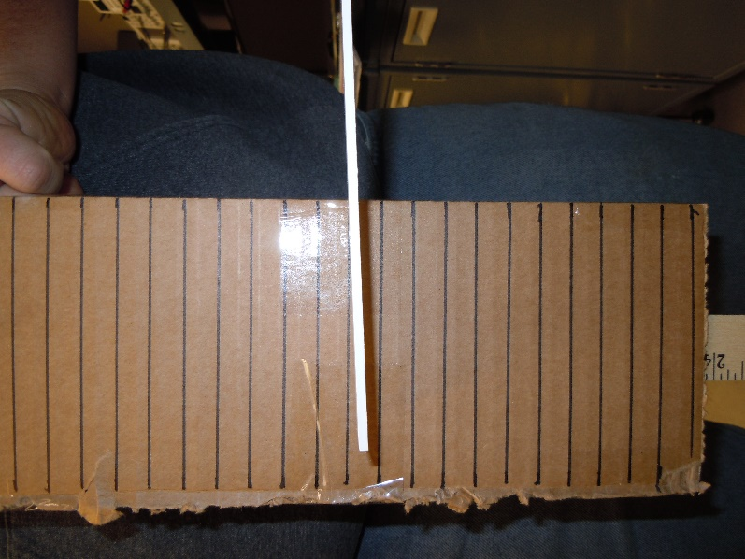
DATA: As binder clips were added the number of oscillations per second decreased.
LONG BEAM TRIAL:
Frames per Second = 29
Length = 16 inches
Thickness = 1/8 inches
Width = 9/8 inches
Number of Clips | Number of Oscillations | Number of Frames | Frequency = Osc/sec = Hz
0 | 25 | 145 | 5
1 | 15 | 145 | 3
2 | 12 | 145 | 12/5
3 | 10 | 145 | 2
4 | 9 | 145 | 9/5
5 | 8 | 145 | 8/5
6 | 7 | 145 | 7/5
7 | 7 | 145 | 7/5
8 | 6 | 145 | 6/5
9 | 5 | 145 | 1
10 | 5 | 145 | 1

SHORT BEAM TRIAL:
Frames per Second = 29
Length = 8 inches
Thickness = 1/8 inches
Width = 9/8 inches
Number of Clips | Number of Oscillations | Number of Frames | Frequency = Osc/sec = Hz
0 | 65 | 145 | 13
1 | 40 | 145 | 8
2 | 24 | 145 | 24/5
3 | 15 | 145 | 3
4 | 12 | 145 | 12/5
5 | 11 | 145 | 11/5
6 | 11 | 145 | 11/5
7 | 13 | 145 | 13/5
8 | 10 | 145 | 2
9 | 7 | 145 | 7/5
10 | 8 | 145 | 8/5

DISSCUSSION: By simplifying the calculation for vibrations it can be determined that as mass is increased the frequency of the vibrations decrease and if the length is reduced it increases the stiffness which in turn increases the frequency of vibrations experienced.

